The DfE replies: Accountability in SEND
By Tania Tirraoro,
(Published on the Special Needs Jungle website in three parts, February 2018)

Last year, the Department for Education offered to answer SNJ readers' questions about SEND. It's not the first time they've done this, you can see the previous session in 2016 here. Once again, you sent your questions in, we grouped them into themes and put them forward and waited. And now, dear reader, the answers are here. Before we start, I'd like to send Patrick, who was in charge of answering your questions but fell ill, our very best wishes for a full recovery; I'm sure you will do the same. This meant an unavoidable delay, but other DfE SEND team members picked up the burning torch and thanks to Laura, Chris and colleagues for this.

Now, of course, it's a given that the answers will not completely satisfy you. Only a properly-functioning SEND system will do that. But with that acknowledged, I for one, appreciate the fact that the DfE has been open enough to do this in the first place and that we have had very good access in general. So, we start off with the first of three posts on the themes of support, EHCPs and accountability. Today, we're bringing you the 'support' section. Remember, this information is direct from the government so you can pass it on to schools, LAs, GPs, NHS providers and anyone else who you think needs this information.

Tania Tirraoro

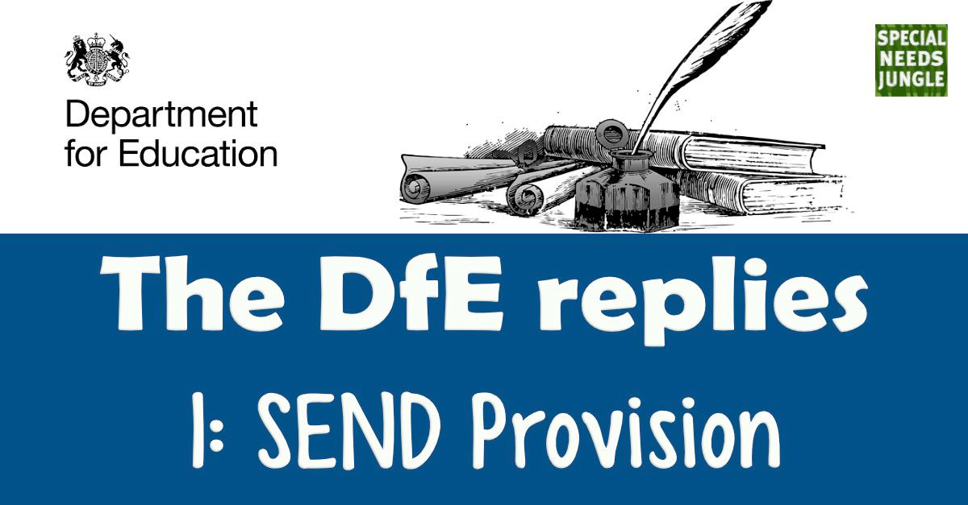

How is the Government supporting schools to improve their SEND provision?

We know that the quality of teaching is central to ensuring that pupils with SEN and disabilities (SEND) are given the best possible opportunity to achieve good results and good outcomes.

In order to be recommended for qualified teacher status, trainee teachers must demonstrate their competence against the Teachers’ Standards. These include a requirement that they, “have a clear understanding of the needs of all pupils, including those with special educational needs and are able to use and evaluate distinctive teaching approaches to engage and support them.”

All maintained nurseries and schools (including academies and free schools) must have a teacher who holds Qualified Teacher Status designated as the SEN coordinator (SENCO). This teacher has responsibility for coordinating the provision for pupils with special educational needs. This member of staff must undertake the National Award in SEN Coordination within 3 years of taking up post if they were not a SENCO for at least 12 months prior to 1 September 2009.

We have provided funding to a range of condition specific organisations to develop resources and training to equip the workforce on SEND. This includes specialist resources in relation to dyslexia, sensory impairment, autism, physical disability and speech and language needs. All the materials funded by the Department are hosted on the SEND Gateway, an online portal offering education professionals free, easy access to high quality information, resources and training for meeting the needs of children with SEND, including a new interactive ‘what works’ resource.

We have recently issued an Invitation to Tender seeking bids to deliver a programme of work to drive education institutions to: prioritise SEND within their Continuous Professional Development (CPD) and school improvement plans; equip schools to identify and meet their training needs in relation to SEND’; build the specialist workforce and promote best practice; and identify and respond to any gaps in the training and resources available for schools. This builds on the work undertaken over the last three years to embed good SEND provision in schools using the SEND review tool.

What is the Government doing to support children and young people with Autism?

We want to ensure that education staff are well placed to support children and young people with autism. The Initial Teacher Training framework of content is ensuring that newly qualified teachers are equipped to support children with special educational needs, including those with autism.

We are currently in discussion about extending our Autism Education Trust contract to deliver autism training to existing education staff in early years settings, schools and colleges. The Department has funded this training since 2012 and it has so far reached more than 150,000 people – not just teachers and teaching assistants, but also support staff such as receptionists, dining hall staff and caretakers, encouraging a ‘whole school’ approach to supporting pupils with autism.

It’s also important that teaching staff can access resources to help them support children on a day-to-day basis in the classroom. We’ve recently published a new resource, developed by ASK Research and Coventry University, that sets out evidence on effective approaches to supporting children and young people with special educational needs, including those with autism, and gives examples of current practice in good and outstanding schools and colleges. It’s designed to help schools and colleges to apply the ‘assess, plan, do, review’ approach recommended in the SEND Code of Practice more effectively.

What is the Government doing about unfair exclusions of children and young people with SEND?

Our school exclusion guidance is clear. Exclusion powers should only be used in particular circumstances and decisions to exclude should be lawful, reasonable and fair. Head teachers should, as far as possible, avoid permanently excluding any child with an EHC Plan.

Ofsted’s assessment of behaviour in schools includes specific consideration of exclusion, including any differences between groups of pupils and parents are encouraged to pursue the appropriate route of redress if they believe a decision to exclude their child has not been made correctly.

We know that pupils with SEN are more likely to be excluded and the Prime Minister has announced a review of exclusions practice, focusing on the experiences of those groups who are disproportionately likely to be excluded from school.

How has the Government worked to ensure that GCSE syllabus changes do not adversely affect pupils with SEND?

The new GCSE and A level qualifications are the result of a long and careful process of reform that started in 2011, with a review of the national curriculum in England. This process has involved extensive consultation and the impact on pupils with special educational needs or disabilities was carefully considered.

The Department for Education consulted on the equality aspects of the GCSE, AS and A level subject content and Ofqual consulted on its proposals for the assessment reforms to the qualifications. More information can be found here. In addition to the equality impact assessments, Ofqual also commissioned independent research, including a review of relevant literature. During the main period of reform, Ofqual’s Equality Advisory Group and Access Consultation Forum were consulted on the regulatory assessment changes. Ofqual continues to meet with equality groups to discuss the reforms including the National Autistic Society, Colour Blind Awareness, RNIB and RNID for example.

Ofqual are currently in the process of evaluating the impact of the reforms. The work began in autumn 2017 following the summer’s first awarding of phase one of the reformed GCSEs and A level qualifications. As part of this work they will be talking to a range of stakeholders including: teachers, educational providers, teacher representative organisations, subject associations and exam boards.

It is worth also noting that if a student is disabled (as defined by the Equality Act 2010) they are entitled to apply for reasonable adjustments. Exam boards have a duty to make reasonable adjustments for disabled students who, because of their disability, would otherwise be at a substantial disadvantage when demonstrating their skills, knowledge and understanding in an assessment.

What measures has the Government put in place to ensure that the new Progress 8 attainment measures do not disadvantage pupils with SEND?

In 2016, we replaced the 5A*-C at GCSE (including English and Maths) headline measure with Progress 8, which compares how much progress pupils make from the end of Key Stage 2 to the end of Key Stage 4 in comparison to other pupils nationally with similar starting points. By focusing on progress, schools are held to account for the performance of all pupils taking relevant qualifications, not just those at the C/D borderline, as every grade from every pupil, including those pupils with SEND, contributes to the school’s performance.

Progress 8 encourages schools to offer a broad and balanced curriculum with an academic core, but it also allows students to study up to three high quality non-GCSE qualifications, thereby ensuring that they still have the opportunity to study a broad range of subjects that reflect individual interests. We recognise that this is an important feature for many lower attaining students, some of whom will have SEND.

Analysis of 2016 performance data illustrates how Progress 8 is benefiting pupils with SEN. In 2016, 37% of SEN pupils achieved a positive Progress 8 score, compared to 20% of SEN pupils achieving at least 5A*-C including English and Maths in 2015.

We have received some feedback about the disproportionate effect that a small number of extremely negative Progress 8 scores can have on a school’s average: for example, where a pupil who did well at primary school does extremely poorly in their GCSEs, compared to others with similar starting points, due to long-term illness in Year 11. This has created concerns that in a small number of cases some progress scores calculated for individual pupils can be so largely negative that they can distort the overall picture of performance for a school. We are refining Progress 8 and the primary progress measures for 2018 in order to reduce the disproportionate impact of the most extreme pupil level progress scores only. These pupils (many of whom will have SEN) will still be included in the progress scores, but the impact they have on the school’s average will be reduced. This change will relate to the progress scores of 1% of pupils nationally - normally no more than one or two pupils in any school.

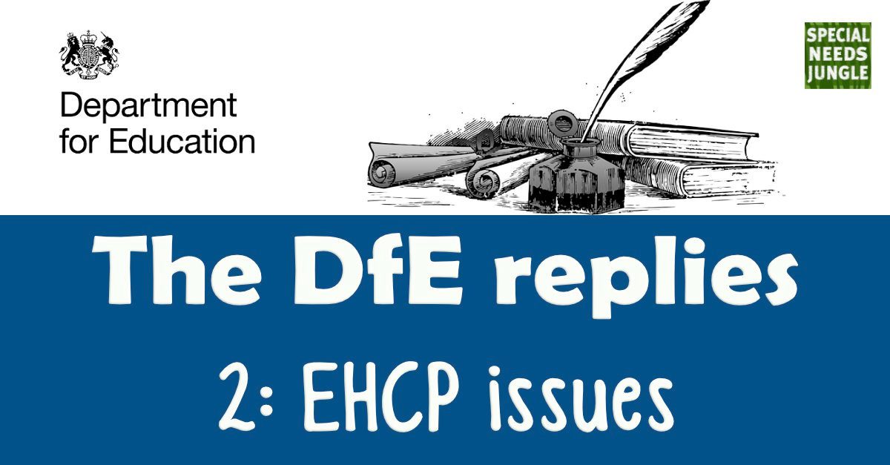

How is the Government ensuring that Education, Health and Care (EHC) plans are of good quality and that the voices of parents and young people are heard?

Since 2014, the department has undertaken a number of activities to drive improvement in the quality of EHC plans, while ensuring that the voices of parents and young people are heard. These include:

Commissioning training programmes and regional events to enable local authorities to share good practice and join peer reviews. Parent representatives attend these sessions, and they now include health and social care representatives.

Legal training workshops delivered jointly with IPSEA for education, health and care leaders with a focus on the requirements for EHC plan assessments and content. All the resources used or referenced in the workshops are available online at:
http://www.sendpathfinder.co.uk/send-decision-making-and-the-law-workshops.

A webinar has also been created providing an overview of the learning at the workshops, this resource can be found online at:
http://www.sendpathfinder.co.uk/send-decision-making-and-the-law-webinar.

The Department’s SEND Adviser team continues to provide feedback on the structure and content of EHC plans as part of their regular work with local authorities. They have also provided a similar service in relation to the transition process. Where specific issues have been raised about a local authority’s EHC plan process or quality from, for example, the local Parent Carer Forum, they have also worked with that local authority. The Advisers also identify local authorities with some good practice around EHC plans and share this.

Clear guidance on developing EHC plans is in the SEND Code of Practice and example EHC plans are online at http://www.sendpathfinder.co.uk/coordinated-assessment-process. The Council for Disabled Children also produced some example EHC plans designed to help practitioners write good quality plans: https://councilfordisabledchildren.org.uk/help-resources/resources/education-health-and-care-plans-examples-good-practice

What is the Government doing to promote personal budgets?

The Department funded KIDS to produce Making it Personal 2, a suite of resources to inform professionals and parents about personal budgets. The resources can be found at:
http://www.kids.org.uk/mip2.

There were 6,442 personal budgets in place for EHC plans issued or reviewed during the 2016 calendar year. You can find out more about personal budgets from the SEND Guide for Parents and Carers:
https://www.gov.uk/government/publications/send-guide-for-parents-and-carers
Page 25 deals with personal budgets.

There is also guidance aimed at local authorities, schools, colleges and other educational settings available on the SEND Gateway at: http://www.sendgateway.org.uk/resources.making-it-personal-3-mip3.html

How does the Government provide funding for pupils with high needs to ensure their educational support is delivered?

The SEND Code of Practice places clear responsibilities on schools to identify and address the needs of all their pupils with SEN and disabilities, including those with high-level needs. This includes meeting the costs of additional SEN support for all pupils up to £6,000. If a pupil requires additional support that costs more, then the school may speak to the local authority about receiving top-up funding from the authority’s high needs budget.

If any school has a high proportion of pupils with high needs, the local authority can provide extra funding to the school, again from its high needs budget, so that the school can meet the extra costs involved in providing this support. These arrangements were introduced in 2013, partly to avoid what was happening in some areas: schools were labelling pupils as having high needs or persuading parents to seek a statutory assessment leading to a statement of SEN simply to secure extra funding for the school.

We have published the full detail of the new school, high needs and central school services national funding formulae, and the impact they will have for every local authority. The introduction of the national funding formulae is supported by a significant extra investment of £1.3bn across 2018-19 and 2019-20, over and above the budget announced at the 2015 spending review.

We are also committed to reforming the funding for children and young people with high needs. The additional investment we are putting in means that every local authority will see a minimum increase in high needs funding of 0.5% in 2018-19, and 1% in 2019-20. Underfunded local authorities will receive up to 3% per head gains a year for the next two years. Overall, local authorities will gain 4.6% on average on their high needs budgets.

What is the Government doing about funding for SEND Transport?

Local authorities must provide school transport for children of compulsory school age who cannot reasonably be expected to walk to school because of their mobility problems or because of health and safety issues related to their SEND.

They have a duty to publish a transport policy statement each year, specifying the travel arrangements they will make for 16 to 18-year-olds (and those who started their programme of learning before their 19th birthday) to access further education and training. These arrangements do not have to be subsidised or free, but local authorities are expected to make reasonable decisions based on the needs of their population, the local transport infrastructure and the resources available. Local authorities have to provide free transport to adults aged 19 or over, including those with an Education, Health and Care (EHC) plan, if they have deemed it necessary to make arrangements for them.

Local authorities are spending nearly £1bn each year to provide home to school transport, with around £600m of this being spent on transport for pupils with SEN. In light of the Inquiry recently held by the charity ‘Contact’ regarding transport for disabled children, the Secretary of State for Education has agreed to review the statutory guidance on school transport for children of compulsory school age to ensure it is clear.

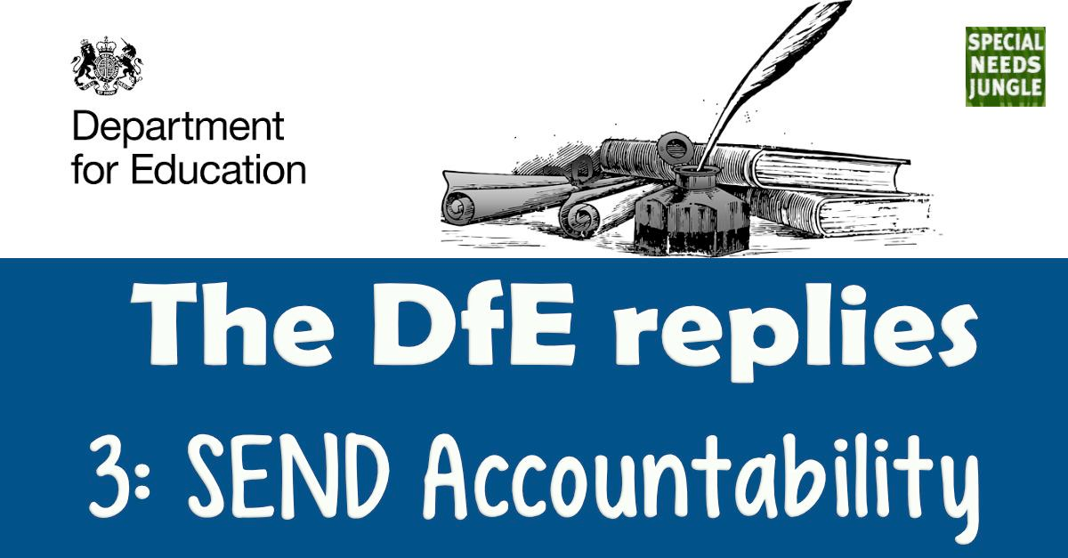

What support is available to parents and young people who wish to complain about the SEND support that they are getting in schools?

The publication, ‘Special educational needs and disability: a guide for parents and carers, contains a wealth of information about rights of appeal and the support services available – see the ‘Challenging or disagreeing with decisions’ section in the guide.

Many issues can be resolved through local conversations with your child’s school. This could be with either, or both, the class or form teacher and the SENCO and could involve senior school leaders if needed. Where a pupil is receiving SEN support, schools should talk to parents regularly to set clear outcomes and review progress towards them, discuss the activities and support that will help achieve them, and identify the responsibilities of the parent, the pupil and the school. The SEND Code of Practice is clear that schools should meet parents of those identified at SEN Support at least three times each year (paragraph 6.65), but parents can request more meetings than this if needed.

A copy of every school’s complaints procedure should be easily available and is often published on the school’s website and the school’s SEN Information Report should include arrangements for handling complaints. Parents can also ask the local authority to use their disagreement resolution service to help resolve issues with a school, if the school complaints route doesn’t resolve things.

Parents and young people can appeal to the First-tier Tribunal (Special Educational Needs and Disability) if they disagree with certain decisions made by their local authority in relation to EHC needs assessments and plans. Appeals must be made within two months of the date of the decision that is causing concern, or within one month of the date of the mediation certificate, whichever is the later.

"The SEND Code of Practice is clear that schools should meet parents of those identified at SEN Support at least three times each year (paragraph 6.65), but parents can request more meetings than this if needed."

Before making an appeal, parents and young people must contact a mediation adviser to consider whether mediation might be a way to resolve the disagreement with the local authority. The only exception to this is where a parent or young person wants to make an appeal only about the school or other educational institution named in the EHC plan – in these circumstances, there is no obligation to contact a mediation adviser.

The SEND Tribunal emphasises that it aims it to be accessible, so it should not be necessary to employ legal support when making or defending an appeal. No additional weight is given to evidence because it is presented by a lawyer and many parents pursue their case successfully without legal representation. You can find more information about the Tribunal via this web link:
www.gov.uk/courts-tribunals/first-tier-tribunal-special-educational-needs-and-disability

How is the Government holding local authorities to account for their performance?

We use intelligence from a wide range of sources to understand where services are working well, where they could do better, and to focus our resources on where we can make a difference. This includes activity the Government funds, surveys, research and SEND inspections, feedback from parents and from our team of professional SEND advisers who work directly with local authorities.

We are clear that improvement is an on-going process and where the Department identifies that local area performance is a particular concern we work with partners, such as NHS England, to engage with senior leaders, and have seen a proactive and positive response.

We have been encouraged by the local authority and Clinical Commissioning Groups’ (CCGs) joint ownership of SEND Ofsted/CQC inspection findings. Inspected local authorities have been very proactive in sharing their learning and this has been a key feature of well-developed regional working, including through the SEND local authority regional networks, funded by the Department for Education. Although not formally required to do so, areas with no significant concerns are also producing action plans to address their areas for development.

Following the publication of a SEND inspection report containing significant concerns, the Department immediately follows up, working with NHS England to do so. Ministers also write to local authorities and CCGs in all local areas that have had their inspection report published; and write again, after 12 months, to those areas identified by the inspections as having significant weaknesses.

What is the Government doing to ensure high quality SEND provision within every local area?

Local authorities, as well as schools and other education providers, have important responsibilities for children and young people with SEND, set by the Children and Families Act 2014. This must be reflected in the published local offer of SEND provision and services. The Act requires local authorities to keep the provision for children and young people with SEN and disabilities under review (including its sufficiency), working with parents, young people, and providers. We have provided guidance on carrying out these strategic reviews.

£215m in capital funding has been provided from 2018 to 2020 for local authorities to increase school capacity and make it easier for children with special educational needs and disabilities to access good school places. Local authorities, through consultation with local stakeholders, should decide how best to spend their allocation to meet local needs.

The Department committed £23m of additional funding in 2016-17 to support strategic planning of high needs provision.

What is the Government doing to improve joint working between education, health & social care services?

The Ofsted / CQC local area SEND inspections are proving to be a strong lever to bring together local authorities and their CCG counterparts. We are also trialling extending powers of the First-tier Tribunal (SEND) to make non-binding recommendations about the health and social care aspects of EHC plans. The trial will apply to decisions made and EHC plans issued/amended from 3 April 2018 and will run for two years.

To support improvements in joint working, we are funding a consortium of partners, including the Council for Disabled Children and Contact, to work with health and social care partners. In addition, the 2017-18 NHS Provider Contract for NHS Trusts, includes, for the first time, a requirement to report on meeting the 6-week deadline for health input into EHC plans.

The Transforming Care programme is working to improve services across education, health and care for children and young people with learning disabilities, autism or with behaviours that challenge and/or a mental health condition. Through this, NHS England published guidance on commissioning quality services and provision for children, including promoting joint working.

The Department for Education also published, in November, the Lenehan Review of residential specialist schools and colleges which explored problems in this area. We are committed to responding to the review and will establish a National Leadership Board for Children and Young People with High Needs, reporting to the Minister for Children and Families.

What is the Government doing to improve joint working between education, health & social care services?

The Ofsted / CQC local area SEND inspections are proving to be a strong lever to bring together local authorities and their CCG counterparts. We are also trialling extending powers of the First-tier Tribunal (SEND) to make non-binding recommendations about the health and social care aspects of EHC plans. The trial will apply to decisions made and EHC plans issued/amended from 3 April 2018 and will run for two years.

To support improvements in joint working, we are funding a consortium of partners, including the Council for Disabled Children and Contact, to work with health and social care partners. In addition, the 2017-18 NHS Provider Contract for NHS Trusts, includes, for the first time, a requirement to report on meeting the 6-week deadline for health input into EHC plans.

The Transforming Care programme is working to improve services across education, health and care for children and young people with learning disabilities, autism or with behaviours that challenge and/or a mental health condition. Through this, NHS England published guidance on commissioning quality services and provision for children, including promoting joint working.

The Department for Education also published, in November, the Lenehan Review of residential specialist schools and colleges which explored problems in this area. We are committed to responding to the review and will establish a National Leadership Board for Children and Young People with High Needs, reporting to the Minister for Children and Families.

How does the Government intend to implement the UN Committee’s Concluding Observations following their recent Examination of the UK governments SEND provisions?

We have structures in place for monitoring and supporting the implementation of the Children and Families Act 2014 reforms. We will be augmenting these with the new National Leadership Board for Children and Young People with High Needs announced in November as part of the launch of the Lenehan Review of residential specialist schools and colleges. Children and young people with SEND and their families are an integral part of those structures. The most effective way to ensure appropriate follow-up to the UN Committee’s Concluding Observations is to ensure that consideration of the issues is addressed in those contexts.

