FEEDBACK FROM SURVEY ABOUT THE SEN CONSULTATION,
CARRIED OUT SUMMER 2017

This data was collected after holding an Open Forum meeting when a council representative came along and gave a presentation about the proposed cuts. This was before the consultation was extended.
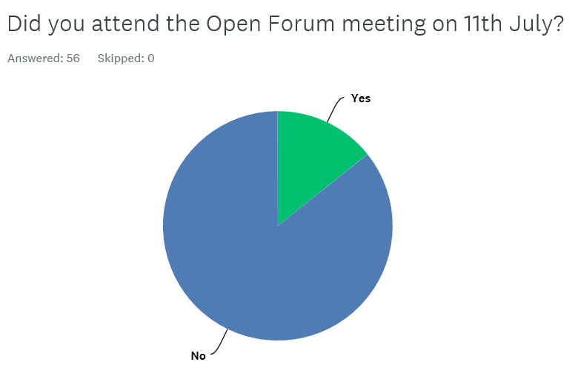

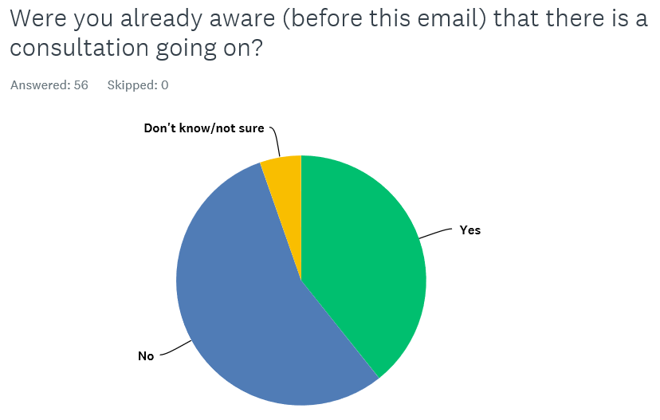

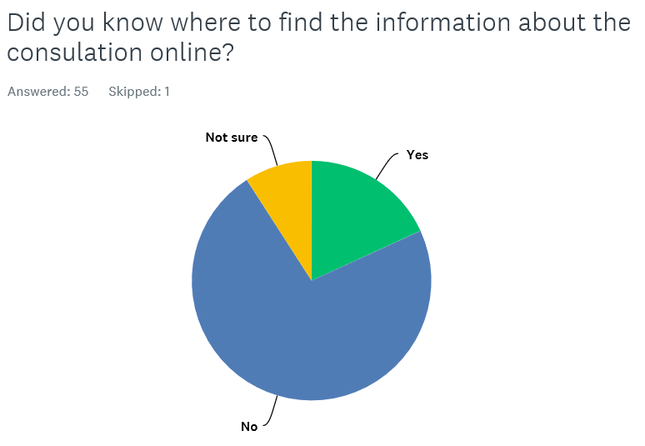

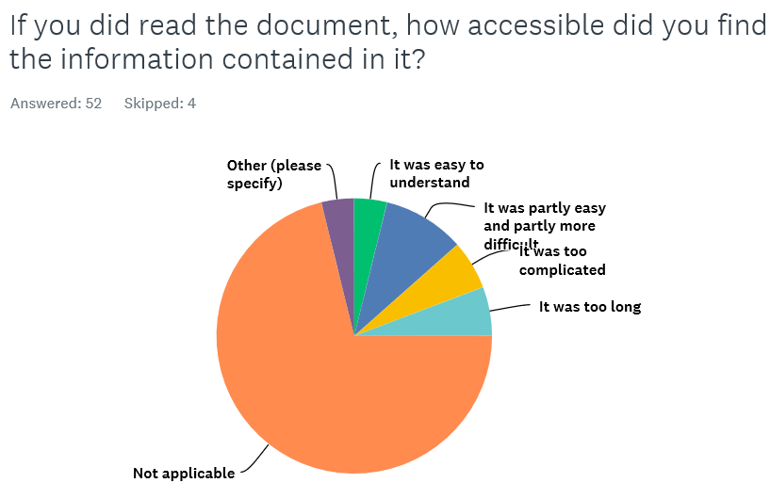

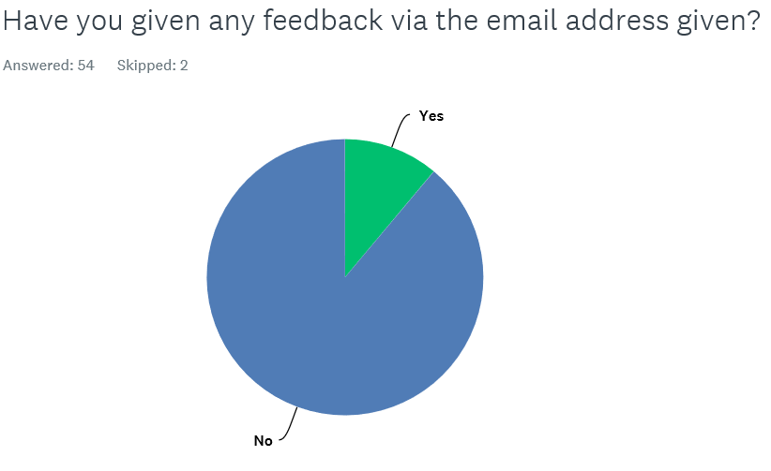

Please use this space if there is anything else you would like to tell us about the consultation process or its content.

- I am very concerned about the focus on behaviour & treating this as different to SEMH or any other disability. This is a symptom of many other issues and not an act of wilful or naughty behaviour by a children. Behaviours are often the only way that children are able to demonstrate their distress. Behaviour is language! Even children who are compliant at School may display their anger and violence at home. What support is available to parents? I have only come across the Behaviour Support Team whom are Teachers - they have no clinical experience or Psychological qualifications. I do not see how under the current proposed plan they can be it forward as the experts for children with mental health difficulties in School. I am greatly concerned by their lack of expertise. I would also add that there is a distinct lack of expertise in the Educational Psychology Team, again Teacher with additional qualifications but no clinical experience. I am very concerned for my children under this new system. The punitive behavioural approach will not work!
- The consultation should be extended and ALL parents of SEND children should be notified either via post to their home or via the child/school. Not many parents have time or energy to read, analyse and feed back on a complicated document, especially over the school holidays. It needs to be made much more simple - give us a list of the main points and we can read the rest if we want. Also needs to be translated into other languages that are common in the Bradford area. And a survey type form to feed back with, including easy to answer questions needs to be used too.
- Was not widely communicated to parents
- I'm a busy working mum caring for a young person with a complex disability I do not have enough hours in the day or headspace to read these documents
- I e-mailed the address given on the local offer page on 7/7/17 asking what events or consultation was planned with parents as I couldn't attend the event on 11/7/17. I hadn't received any response by 25/7/17 and so got in touch with my local councillors, who responded immediately and said they forwarded the e-mail to the Strategic Director for Children’s Services. I got no response till 4/8/17, when I received an e-mail from the Children's Services Director who said "we did answer your question it appears that this may not have been sent directly back to yourself so offer apologies for any inconvenience". They said that the parent and carers forum would communicate with parents, and that they had attended the forum. They didn't give any further information about opportunities for consultation as I had asked for. I then received a further e-mail on 8/8/17 from the Education, Employment and Skills Project Manager stating this same information, and saying that she had been on leave for 2 weeks and this is why I hadn't had a response (bearing in mind my e-mail was sent a month prior to this).

- I will be looking into the consultation document after someone made me aware of the changes...I am very concerned of the changes for deaf children in mainstream school...my son who is deaf and wears cochlear implants is going into mainstream secondary school in September 2017. He needs to continue to get the same level of support he got in Girlington primary school. The secondary school he us going to needs the support to know what support provision he needs as they are new to having a deaf child in school and i want them to use the money wisely for his needs..ie travel training...which should have been done before he starts in September ....I will also be looking at having his ECHP reviewed again as in the plan it does not state how many hours of support he will be getting and with the changes he will miss out vital support a child with special educational needs when they start secondary school..i.e. .changes, new teachers/children. ..The anxiety /confusion of being in year 7.
- Less parents have been informed. The consultation has not been done openly. Hardly any parent’s views and decisions have been taken. We are not happy with this decision that has been made by the council. First they closed down the deaf schools then put the children into an ARC which was never been managed in the right way HANSON ACDEMY now this new change. Who will monitor all this no one has monitored Hanson though it has been provision for the deaf. Do you really think school will buy support in.? Soon the council will say keep the deaf children at home we can't afford for them to go to school. We don't want this consultation to go ahead.
- It's a disgrace that I have a child on the SEND register and have not been made aware of the consultation.
- None
- Only reason I didn't attend the consultation in July is due to work commitments!
- Feel that the consultation is not easily accessed and is not being promoted making it easier for the council to push through just what they want.
- It is not in the best interests disabled children, but just another cost cutting exercise by the local authority. Ultimately, it's the children and families that take the brunt of this, by the lack of service to meet the needs.

