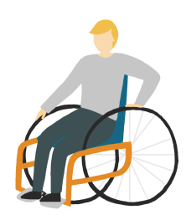 What you should remember when designing services:
Helping Bradford Young People to

- Are the services set up well for young people and their needs, not just centred on the professional’s needs?

2) All support is accessible - easy to get to, get into and find out about? Photos of workers, video tours of buildings, young person friendly websites, young people reviews and audits of services, able to attend the service with someone you trust, interactive social media pages, online chat, helplines, drop-ins.
They need to be at convenient times for us as well, not just for you!
3) Support should be more flexible, offered outside school’s teaching time, in a variety of ways and should not interrupt our education which potentially harms our chance to build a positive future for ourselves.

4) Support should be young person friendly – bright, colourful, comfortable environment, not intimidating,
open and honest, easy to understand and not too formal.

5) Workers should be engaging, knowledgeable and positive for children and young people to be around,
They should be a good role model for us to aspire to.

6) Is the referral process uncomplicated, open to a range of workers and can it accept self-referrals? In all

referrals made, is there an opportunity for us to have our voice heard telling our story in our own words?

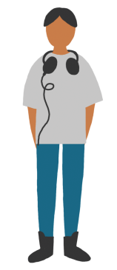7) We are given as much information as we need by the referrer so that we understand why it is being made, who we will see, what will happen, in what time frame and what our rights are.

8) We do not want to have to say our story over and over again to get the help we need. There should be one place we go.

9) We want services to work together to tackle stigma. We want to use support that we are all aware of and is not stigmatising to use.

10) We need to get the help as soon as we ask for it so we do not have to cope alone! Match us up with support (a buddy) at the time of referral, whilst finding the right service for us.

11) We need help that is professional but approachable. We are not adults, do not create services that are too formal that we cannot connect with.
12) Relationship building is the most important factor and made comfortable for us? Would this approach engage all communities and adapt to individuals? If you do not build a relationship with us, we are not going to want to use your service.
13) Is the service a ‘do with’, not a ‘do to’ service? We need to share some of the power, learn how to care for ourselves and not panic when a professional is not there. Build our (and our close family’s) resilience so that we can cope without you.

14) We should be able to share in decision making and be kept informed. We want systems where we are not left guessing what is happening and what you are thinking e.g. feedback from workers, visible care plans and true participation.

15) Services need to clearly tell us about our rights like: confidentiality, how to make a complaint, choices that we can make such as time of appointment, location, ability to choose and change worker.

16) Does the service believe in participation and provide us with opportunities to be involved and shape services?

17) When we are mentally (not physically) old enough to transition this should be a smooth, supportive and safe move taken at our speed.

18) If we do not turn up for an appointment, please give us another chance – create a safety net that supports
our engagement. Support and help us to open the door to your services and reduce the times we do not attend.

19) One size does not fit all, use a range of approaches: outreach, group work, peer support, one to one, creative, active, talking therapy, drop in – co-design these approaches with us!
Ask yourself…if you were a young person would you feel comfortable with how it’s run?
Would you feel comfortable not knowing anything about the person you were talking to and expected to confide in?
Are your services there for any young people that need it or just accessible for a select few?
www.thrivebradford.org.uk

